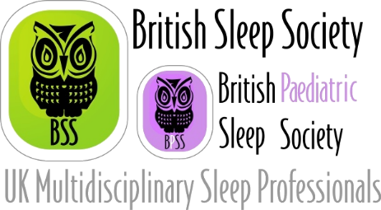
Nomination for Post:

British Sleep Society
BSS Education Committee Lead
Terms 06-2021; period of 2 years

Candidate:
Name Job Title Address / email

Personal Statement (500 word limit. Continue on new sheet if necessary):

Proposer

Name
(block capitals)

Seconder

Name
(block capitals)

*Note: please ensure your proposer and seconder are current members of the Society.

Return form by 15th April, 2021 to admin@sleepsociety.org.uk

