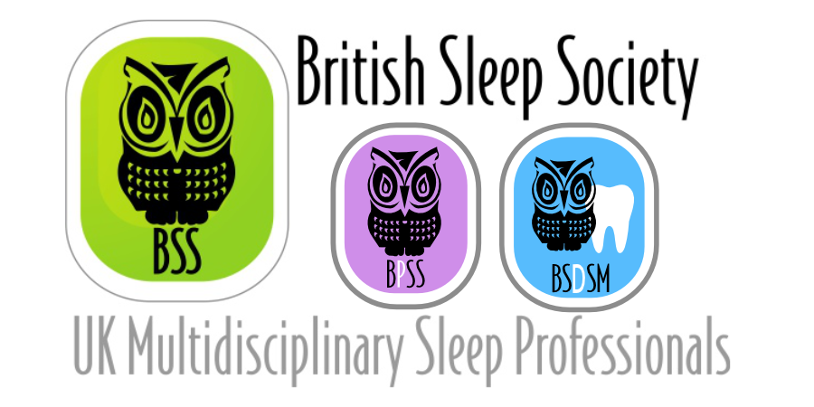
BSS Student Registration Grant Application Form
Closing Date: Thursday 30th September 2021
Name

Email

Telephone Number

Place of Education or Training

Course Studied
Address

Detail of any other funding to attend the conference (including source and amount applied for)
Details of how much you would like to apply for?
(Maximum £50)
Reason for wanting to attend the conference (250 words max)

By signing this form you agree that, if successful, you will attend the conference as per your application and produce a written article for the BSS Newsletter and/or website. Failure to comply with any part of this will result in refusal of the grant.

SIGNED DATE

Terms and Conditions

Grants are available to British Sleep Society Student members only.

Retrospective applications will not be considered.

Grants are awarded at the discretion of the BSS and the treasurer’s decision is final.
- Applicants will be responsible for their own arrangements for study leave from their trust / hospital / department.

Applicants who receive support from other sources that meets their costs in part or in full are required to inform the BSS Office of the amount(s) as soon as possible.

The maximum grant available is £50 per person.
- If awarded, the grant of up to £50 will be subsequently paid to reimburse part of your BSS Virtual Sleep 2021 registration cost.

Please return form to events@sleepsociety.org.uk
by Thursday 30th September 2021

