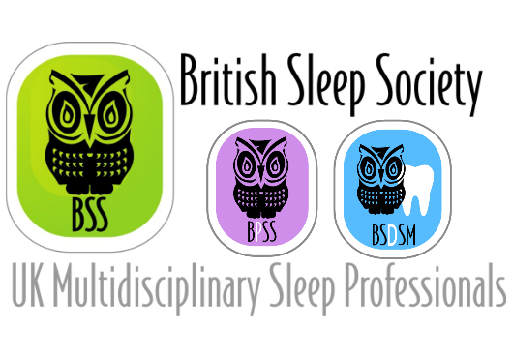

Nomination for Post:

British Sleep Society
BSS Early Career Professional (ECP) representative within the Education Committee
Terms 2022-2024; period of 2 years

Candidate:
Name Job Title Address / email

Personal Statement (500 word limit. Continue on new sheet if necessary):

Proposer

Name
(block capitals)

Seconder

Name
(block capitals)

*Note: please ensure your proposer and seconder are current members of the Society.

Return form by Monday 14th March 2022, 12pm to admin@sleepsociety.org.uk

